Asbo Forged Cads Explanation!
Exhibit P

- We Took All Cad numbers from Cad 10967 of the 07/06/2014.
- When reading a Cad that the police and the Enfield Council adduced in the Asbo Application you must take notes of various aspects.

- You will notice numbers and dates at the start of each Cad that the police and the Enfield Council labelled as.
- Linked: explicitly to
- Linked: implicitly to:
- One of the points to keep in mind is the date that the squatters occupied Progress way on the 7th 8th of June 2014.
- In both 1st Magistrates Court & 2nd Crown Court Asbo applications the Linked files are the same and each CAD in each application shows the same Information.
- Any Dates before the 07 & 08th of June 2014 is in fact Crown Rd, this also includes the dates of the 07th & 08th June 2014 also being Crown Rd.
- The dates of 07 & 08th of June 2014 are the only dates in the Asbo application that have any form of victims for the Crown to have prosecuted me.
- Crown Rd
- A
- A
- A

- Grid References.
- The police made the 02nd 999 call to the police while on duty Cad 1047 Pc Shinnick from the police Patrol Centre
- CADS that the police took from more than one location other than progress way and used against me in the Court of Law
- Cad 10471
- Redacted Information that would have proved my innocence.
- Remarks made by Police Officers and civil servants.

PRINTED AT 15:56 11: AUG:14 GPC
SINGLE INCIDENT PRINTOUT
INCIDENT No. 2410:08JUN14
711243 YE DIVISON
Time Date
Illegal rave going on opposite A&J Cars

- CROWN RD
- CROWN RD is now known as Travis Perkins, but the original companies name was the “Man Building.”
- The Enfield Council had Control of the assets for the building until they sold it.
- https://www.google.com/search?q=A%26J+Cars+enfield&rlz=1C1CHBD_en-GBGB926GB926&oq=
A26J+Cars+enfield&aqs=chrome..69i57j46i13i175i199j0i13i30j0i8i13i30.5243j0j15&sourceid=chrome&ie=UTF-8

- This is a up to date picture.
- https://www.google.com/maps/@51.6490462,0.0539904,3a,75y,0.34h,74.14t/data=
!3m6!1e1!3m4!1s0uXv0C7xlJMrM0NAZ91gqA!2e0!7i16384!8i8192

- This is a picture in 2014 what is relevant to my defense as it has the squatter section still on the gate.
- https://www.google.com/maps/@51.6497149,-0.0538192,3a,75y,115.76h,95.16t/data=!3m7!1e1!3m5!1saz
Wzy_HhHaW6zAbqVnkjvA!2e0!5s20140701T000000!7i13312!8i6656

- My mother put a FOI into the Enfield Council about this building and what we can prove is.
- The Enfield Council & Met Pole force Were receiving complaints about the squatter in this building while I was on curfew for the Gazebo Case / before the Asbo.

- The Enfield Council had Control of the assets for the building until they sold it. “Check my diary dated; 25/04/2014.”
- https://www.enfieldindependent.co.uk/news/11459487.the-man-building-Enfield-wrecked-by-graffiti/

- Enfield Patrol Base
- Address: Great Cambridge Industrial Estate, Unit 17-19 Lincoln Rd, Enfield EN1 1SH
- This building was a newish building almost next doors to Progress way were Pc Shinnick Made the second 999 call on the 7th of June 2014 to Mett CCC Bow Cad 1047
- It is the building under construction in front: “It was built by the 6th of June 2014 and running as a company.”
- When using Google Maps look in the right corner for the words street view and click on the clock looking icon for a date timeline.
- https://www.google.com/maps/@51.6422795,0.0606787,3a,90y,29.12h,102.53t/data=!3m6!1e1!3m4!1sWe3HJMmpd7lRY1D-RtbAeg!2e0!7i13312!8i6656

- Progress Ways back entrances Location is down this Ally “Next doors almost to the then newish Patrol Base.”
- https://www.google.com/maps/@51.6421005,0.0607902,3a,75y,91.33h,69.57t/data=!3m6!1e1!3m4!1sWPsltiqjqolmxvz9KUutXA!2e0!7i13312!8i6656

End:

One Original Forged Asbo Cad Exhibit
Exhibit *****
- Example Cad
- Police Cad 1047
- Dated 07/06/2014.

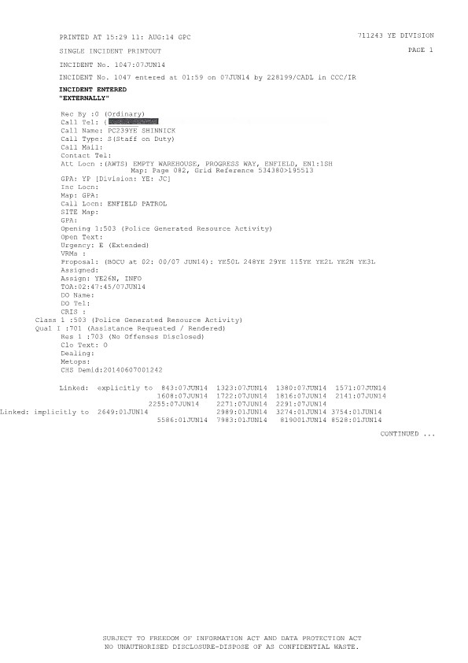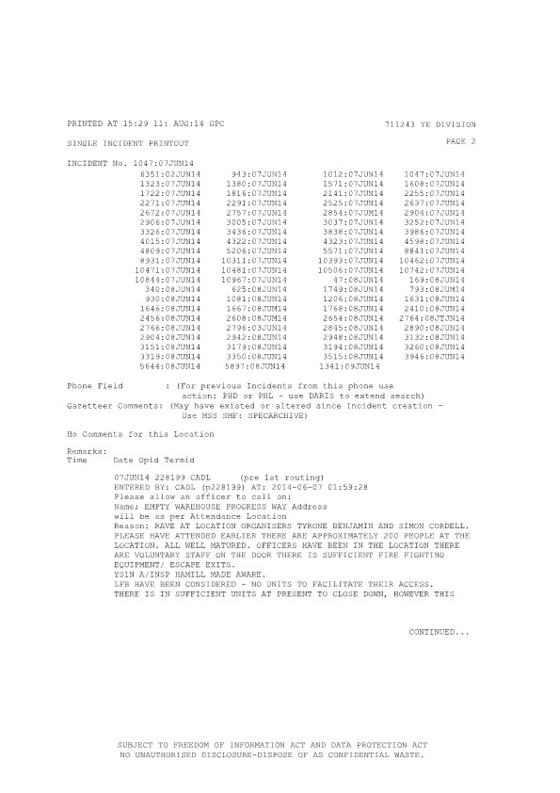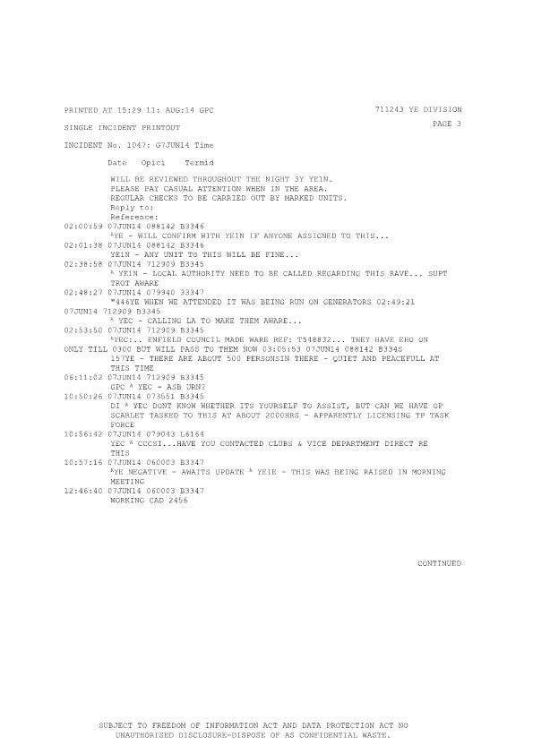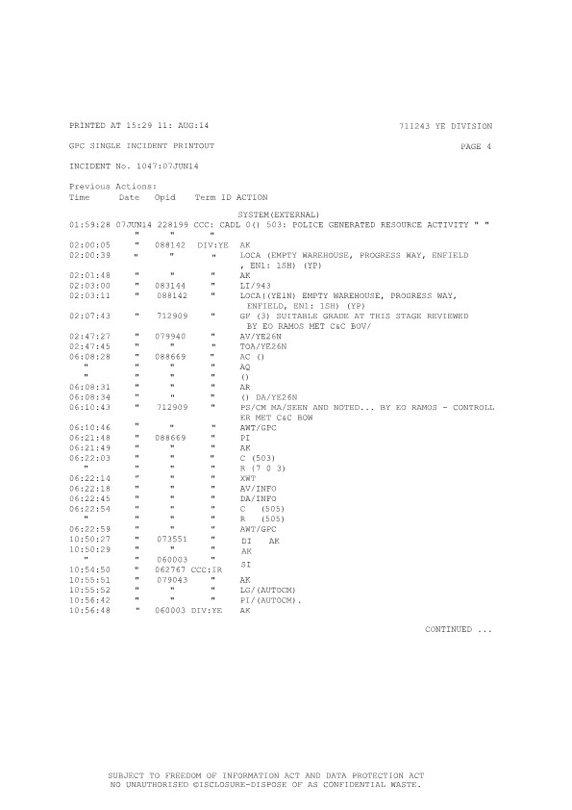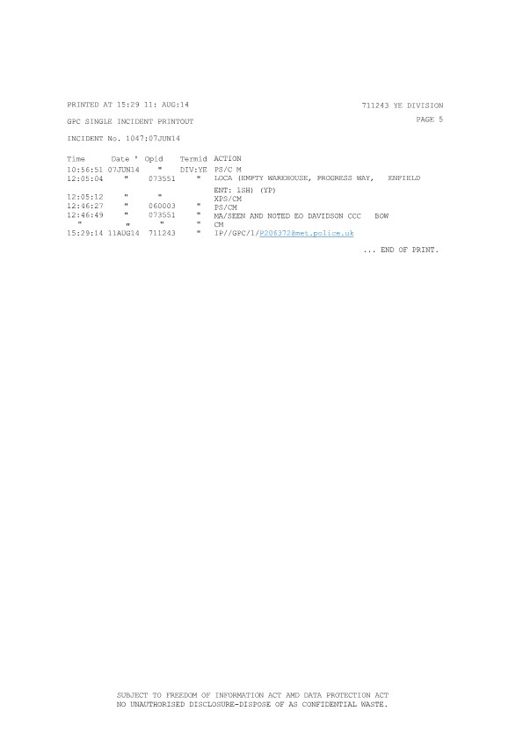

- END

Asbo Forged explicitly to Linked Example!
Exhibit *****

Linked: explicitly to:
Linked: implicitly to:
943:07JUN14  2649:01JUN14  3274:01JUN14  1081:03JUN14  2141:07JUN14  2456:07JUN14  2672:07JUN14  2906:07JUN14  3326:07JUN14  4015:07JUN14  4809:07JUN14  8931:07JUN14  10471:07JUN14  10844:07JUN14  10742:07JUN14  340:08JUN14  930:08JUN14  1646:08J0N14  2456:08JUN14  2766:08JUN14  2904:08JUN14  3151:08JUN14  3319:08JUN14 | 2989:01JUN14  1571:07JU14  8528:01JUN14  2255:07JUN14  2525:07JUN14  2757:07JUN14  3005:07JUN14  3436:07JUN14  4322:07JUN14  5206:07JUN14  10311:07JUN14  10481:07JUN14  10967:07JUN14  10506:07JUN14  625:08JUN14  1667:08JUN14  2608:08JUN14  2796:08JUN14  2942:08JUN14  3179:08JUN14  3350:08JUN14  3515:08JUN14  3946:08JUN14 | 5586:01JUN14  3190:01JUN14  6851:02JUN14  1047:07JUN14  1608:07JUN14  1380:07JUN14  2271:07JUN14  2601:07JUN14  2354:07JUN14  3037:07JUN14  3838:07JUN14  4323.07JUN14  5571:07JUN14  10393:07JUN14  47:08JUN14  749:08JUN14  1206:08JUN14  1768:08JUN14  2654:08JUN14  2845:08JUN14  2948:08JUN14  3194:08JUN14  5644:08JUN14 | 7983:01JUN14  3754:01JUN14  5897:03JUN14  1722:07JUN14  1816:07JUN14  2291:07JUN14  1323:07JUN14  2637:07JUN14  2904:07JUN14  3252:07JUN14  3986:07JUN14  4598:07JUN14  8841:07JUN14  10462:07JUN14  169:08JUN14  793:08JUN14  1631:08JUN14  2410:08JUN14  2764:08JUN14  2890:08JUN14  3132:08JUN14  3260:08JUN14  1341:09JUN14

Grid Reference Finder Instructions for Asbo Cads
Exhibit *****

- The website link below can is to check the grid reference number for inconsistencies to which they show.
- https://gridreferencefinder.com/

All Wrongfully Asbo Submitted CAD’s For 1st June 2014
All Cad numbers from Cad 10967 07/06/2014
Exhibit *****

CAD |  | Num |  |  | Date | Time | Page
CAD | Cad 1 of the day | 2649 | Missing CAD  Crown Rd |  | 01/06/2014 | Missing CAD | Page Mag  2 –
CAD | Cad 2 of the day | 2989 | Missing CAD  Crown Rd |  | 01/06/2014 | Missing CAD | Page Mag  2 –
CAD | Cad 3 of the day | 3190 | Missing CAD  Crown Rd |  | 01/06/2014 | Missing CAD | Page Mag  2 –
CAD | Cad 4 of the day | 3274 | Missing CAD  Crown Rd |  | 01/06/2014 | Missing CAD | Page Mag  2 –
CAD | Cad 5 of the day | 3754 | Missing CAD  Crown Rd |  | 01/06/2014 | Missing CAD | Page Mag  2 –
CAD | Cad 6 of the day | 5586 | Missing CAD  Crown Rd |  | 01/06/2014 | Missing CAD | Page Mag  2 –
CAD | Cad 7 of the day | 7983 | Missing CAD  Crown Rd |  | 01/06/2014 | Missing CAD | Page Mag  2 –
CAD | Cad 8 of the day | 8528 | Missing CAD  Crown Rd |  | 01/06/2014 | Missing CAD | Page Mag  2 –

All Wrongfully Asbo Submitted CAD’s For 2nd June 2014
All Cad numbers from Cad 10967 07/06/2014
Exhibit *****

CAD |  | Num |  |  | Date | Time | Page
CAD | Cad 1  of the day | 6851 | Missing CAD  Crown Rd |  | 02/06/2014 | Missing CAD | Page Mag  2 –

All Wrongfully Asbo Submitted CAD’s For 3rd June 2014
All Cad numbers from Cad 10967 07/06/2014
Exhibit *****

CAD |  | Num |  |  | Date | Time | Page
CAD | Cad 1  of the day | 1081 | Missing CAD  Crown Rd |  | 03/06/2014 | Missing  CAD
CAD | Cad 2  of the day | 5897 | Missing CAD  Crown Rd |  | 03/06/2014 |  | Page Mag  2 –

All Asbo CAD’s For 7th June 2014
Exhibit *****

[Backwards Timestamps.]
[Wrong Locations.]
[Police on Active Duty Making Emergency 999 Calls.]
[Missing Police Cads.]
[Forged Cads.]
[Reacted Information.]

CAD |  | Num |  |  | Date | Time | Page
CAD | Cad 1  of the  day | 943 | Missing  CAD  Crown Rd |  | 07/06/2014 | Missing  CAD
CAD | Cad 2  of the  day | 1012 | (In Progress  Way grid ref  534380,  195513) | Progress  Way / | 07/06/2014 | 01:53 | Page  Mag  2 –  178,179,  180,181
CAD | Cad 3  of the  day | 1047 | (In  Progress  Way grid  ref 534380,  195513  Main cad police Insp HILLMILL  sent to  location progress | Progress  Way / | 07/06/2014 | 01:59 | Page  Mag  2 –  209,210,  211,212,  213
CAD | Cad 4  of the  day | 1323 | (Lincoln  Way grid 534657,  195453) | Lincoln  Rd  Lumina  Way  Enfield / | 07/06/2014 | 02:41 | Page  Mag  2 –  182,183,  184,185,  186
CAD | Cad 5  of the  day | 1380 | Missing  CAD  Crown Rd |  | 07/06/2014 | Missing  CAD
CAD | Cad 6  of the  day | 1571 | Missing  CAD  Crown Rd |  | 07/06/2014 | Missing  CAD
CAD | Cad 7  of the  day | 1608 | (In  Progress  Way grid  ref  534380,  195513) | Progress  Way Great  Cambridge | 07/06/2014 | 03:34 | Page  Mag  2 –  219,220,  221
CAD | Cad 8  of the  day | 1722 | (Orchard Terrance Progress  Way grid  ref  534380,  195513) | Blocked  Out / | 07/06/2014 | 03:58 | Page  Mag  2 –  187,188,  189
CAD | Cad 9  of the  day | 1816 | (In  Progress  Way grid  ref  534380,  195513) | Progress  Way / | 07/06/2014 | 04:15 | Page  Mag  2 –  190,191,  192,193,  194
CAD | Cad 10  of the  day | 2141 | (Hardy  Way  Grid  Ref  531438,  197711  miles  away  (Gordon Hill) | Hardy  Way | 07/06/2014 | 05:50 | Page  Mag  2 –  195,196,  197,198,  199
CAD | Cad 11  of the  day | 2255 | (Leighton Road  Grid Ref 534144,  195627  Bush Hill Park) | Leighton  Rd Bush  Hill Park / | 07/06/2014 | 06:24 | Page Mag  2 –  200,201,  202,203,  204
CAD | Cad 12  of the  day | 2291 | Missing  CAD  Crown  Rd |  | 07/06/2014 | Missing  CAD
CAD | Cad 13  of the  day | 2271 | (In  Progress  Way grid  ref  534380,  195513) | Progress  Way / | 07/06/2014 | 06:27 | Page  Mag  2 –  205,206,  207,208
CAD | Cad 14  of the  day | 2456 | Missing  CAD  Crown Rd |  | 07/06/2014 | Missing  CAD
CAD | Cad 15  of the  day | 2525 | Missing  CAD  Crown  Rd |  | 07/06/2014 | Missing  CAD
CAD | Cad 16  of the  day | 2601 | (AYLEY CROFT  Grid  Ref  534219,  195697)  Police  Building | Great  Cambridge  Rd / AYLEY  CROFT / | 07/06/2014 | 08:09 | Page  Mag  2 –  222,223,  224,225
CAD | Cad 17  of the  day | 2637 | (1st Time  Laps  08:18)  (In  Progress  Way  grid ref 534380,  195513) | Progress  Way / | 07/06/2014 | 08:18 | Page  Mag  2 –  226,227,  228,229.  230
CAD | Cad 18  of the  day | 2672 | (1st Time Laps 08:16)  (In Progress Way grid ref 534380,  195513) | Progress  Way / | 07/06/2014 | 08:16 | Page Mag  2 –  231,232,  233
CAD | Cad 19  of the  day | 2757 | Missing CAD  Crown Rd |  | 07/06/2014 | Missing  CAD
CAD | Cad 20  of the  day | 2854 | (In Progress Way grid ref 534380,  195513) | Progress  Way / | 07/06/2014 | 08:56 | Page  Mag  2 –  234,235,  236,237
CAD | Cad 21  of the  day | 2904 | Missing CAD  Crown Rd |  | 07/06/2014 | Missing  CAD
CAD | Cad 22  of the  day | 2906 | Missing CAD  Crown Rd |  | 07/06/2014 | Missing  CAD
CAD | Cad 23  of the  day | 3005 | (2nd Time Laps 09:22)  (In Progress Way  grid ref 534380,  195513) | Progress  Way / | 07/06/2014 | 09:22 | Page  Mag  2 –  238,239,  240
CAD | Cad 24  of the  day | 3037 | (2nd Time Laps 09:20)  (Ty ne mouth  Drive miles away  Grid Ref  534375,  198125) | Enfield  Safe Store | 07/06/2014 | 09:20 | Page  Mag  2 –  214,215,  216,217,  218
CAD | Cad 25  of the  day | 3252 | (In Progress Way grid ref 534380,  195513) | Progress  Way / | 07/06/2014 | 10:07 | Page  Mag  2 –  241,242,  243,244
CAD | Cad 26  of the  day | 3326 | Missing CAD  Crown Rd |  | 07/06/2014 | Missing  CAD
CAD | Cad 27  of the  day | 3436 | Missing CAD  Crown Rd |  | 07/06/2014 | Missing  CAD
CAD | Cad 28  of the  day | 3838 | Missing CAD  Crown Rd |  | 07/06/2014 | Missing  CAD
CAD | Cad 29  of the  day | 3986 | (In Progress Way grid ref 534380,  195513) | Progress  Way / | 07/06/2014 | 11:47 | Page  Mag  2 –  245,246,  247,248
CAD | Cad 30  of the  day | 4015 | Missing CAD  Crown Rd |  | 07/06/2014 | Missing  CAD
CAD | Cad 31  of the  day | 4322 | Missing CAD  Crown Rd |  | 07/06/2014 | Missing  CAD
CAD | Cad 32  of the  day | 4323 | (In Progress Way grid ref 534380,  195513) | Progress  Way / | 07/06/2014 | 12:25 | Page  Mag  2 –  249,250,  251,252
CAD | Cad 33  of the  day | 4598 | Missing CAD  Crown Rd |  | 07/06/2014 | Missing  CAD
CAD | Cad 34  of the  day | 4809 | Missing CAD  Crown Rd |  | 07/06/2014 | Missing  CAD
CAD | Cad 35  of the  day | 5206 | (No grid or ATT location)  Crown Rd | Blocked  Out / | 07/06/2014 | 13:57 | Page  Mag  2 –  253,254,  255
CAD | Cad 36  of the  day | 5571 | Missing CAD  Crown Rd |  | 07/06/2014 | Missing  CAD
CAD | Cad 37  of the  day | 8841 | (In Progress Way grid ref 534380,  195513) | Progress  Way / | 07/06/2014 | 20:07 | Page  Mag  2 –  256,257,  258,259
CAD | Cad 38  of the  day | 8931 | Missing CAD  Crown Rd |  | 07/06/2014 | Missing  CAD
CAD | Cad 39  of the  day | 10311 | Missing CAD  Crown Rd |  | 07/06/2014 | Missing  CAD
CAD | Cad 40  of the  day | 10393 | (Great Cambridge Road miles away Grid Ref 534396,  197692  Carter hatch Lane but states behind tops tiles) | Great  Cambridge  Rd / Tops  Tiles / | 07/06/2014 | 22:38 | Page  Mag  2 –  260,261,  262,263,  264,265,  266
CAD | Cad 41  of the  day | 10462 | Missing CAD  Crown Rd |  | 07/06/2014 | Missing  CAD
CAD | Cad 42  of the  day | 10471 | (In Progress Way grid ref 534380,  195513) | Progress  Way / | 07/06/2014 | 22:45 | Page  Mag  2 –  277,278,  279,280

Asbo Cads More Info
Exhibit *****

[Evidence of Forged Police Officer Statements Dates & Cads.]

Dated 19/08/2014.
Accused Date 06/06/2014.
Accused Date 07/06/2014.

- The rest of the 07/06/2014 table is below!
- Statement off: Eric Baker
- Police Officer 219382
- Dated 19/08/2014.
- He is a police officer in London Borough of Enfield and tasked to contact residents of the Borough who had called police to inform them of an illegal rave that took place over Friday 07th June 2014 and Saturday 8th June 2014, in a warehouse in Progress Way Enfield
- On Tuesday 19th August 2014 I contacted the caller of CAD 10471/07June 2014 by telephone that was happy to give an impact statement about how illegal rave affected her and her husband over the above dates mentioned.
- The caller wishes to remain anonymous. I will refer to her as complainant "A" The original notes taken from the below statement are present in my pocketbook serial 370/14, page 1.
- Complainant "a" said it was a warm evening and we had to keep the windows shut because of the noise. The next day we could not even go out into the garden because of the noise. It kept me and my husband up all night and made us very anxious the next day. The illegal rave totally ruined us weakened" This concluded what complainant 'A" said about this matter.

Mr. Simon Cordell will say, “that at no point did he take part in any form of Anti-Social behavior, and he did not organize or hire any equipment to this private house party neither was he attending a rave on the 6th 7th 8th June 2014th?

Witness Statement
- A/Inspector Hamill 201566
- Friday 06th June 2014 Progress Way
- A/Insp Hamill 201566 states; "I have had a CAD created reference 10471 7June dispatched officers to the location to access numbers, crowd dynamics and gather information around times the event is likely to run until ----and also to make contact or identify the potential organizer. Officers have reported back that Tyrone Benjamin and Simon Cordell where at location and to be the believed the event organizers, there were approximately two hundred people in attendance, the event had security officers covering it who had said that they were volunteers and not licensed through SIA. Officers have spoken with staff to confirm that all fire escapes were clear, that there were sufficient fire extinguishers in place and that there were first aid kits available."

Exhibit ****
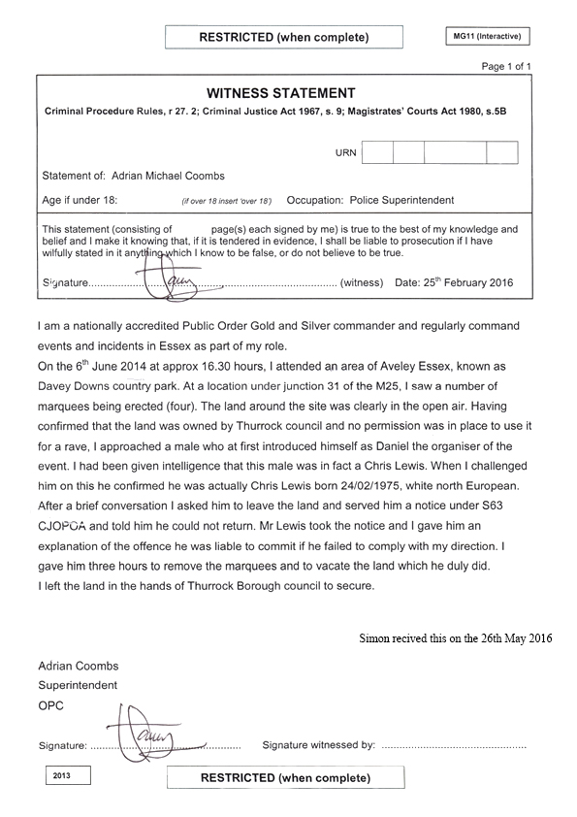

Cads
Exhibit *****

CAD | Cad 43  of the  day | 10481 | (3rd Time Laps 22:47  to 22:44)  (Wood stock Cres  grid Ref 534657,  195453) | Blocked Out / | 07/06/2014 | 22:47 | Page  Mag  2 –  268,269,  270,271,  272
CAD | Cad 44  of the  day | 10506 | (3rd Time Laps 22:47  to 22:44)  (In Progress Way  grid ref 534380,  195513) | Progress Way / | 07/06/2014 | 22:44 | Page  Mag  2 –  273,274,  275,276
CAD | Cad 45  of the  day | 10742 | (Lincoln Way grid 534657,  195453) | Lincoln Rd / | 07/06/2014 | 23:01 | Page  Mag  2 –  281,282,  283,284
CAD | Cad 46  of the  day | 10844 | Missing CAD  Crown Rd |  | 07/06/2014 | Missing CAD
CAD | Cad 47  of the  day | 10967 | (In Albury Walk Miles Away  grid ref 535375.  202125 Cheshunt) | A10 Great Cambridge Rd / | 07/06/2014 | 23:25 | Page  Mag  2 –  285,286,  287,288,  289

All Asbo CAD’s For 08th June 2014
Exhibit *****

- There are 37 CAD/ Incident numbers for the 8th of June 2014, to which there is only seven in the ASBO application and only Cad Number 47 is Progress Way, the rest represent 32 Crown RD other premises then occupied under section 144 LASPO 10 minutes away from progress way. According to the statistics, the call center receives on the 08th of June 2014, 300 people call per hour.
- https://gridreferencefinder.com/

CAD |  | Num |  |  | Date | Time | Page
CAD | Cad 1  of the day | 47 | (In Progress Way grid ref 534380,195513) | Progress Way Enfield /Safe Hal Unit / | 08/06/2014 | 00:00 | Page  Mag  2 –  290,291,  292,293,  294
CAD | Cad 2  of the day | 167 | Missing CAD  Crown Rd |  | 08/06/2014 | Missing CAD | Page  Mag  2 –
CAD | Cad 3  of the day | 340 | Blocked Out Page  Crown Rd | Blocked Out / | 08/06/2014 | 00:29 | Page  Mag  2 –  295,296,  297,298
CAD | Cad 4  of the day | 625 | Lincoln Road, Bush Hill Park, Southbury, London Borough of Enfield, London,  534152,195940  To Far | Lincoln Rd / | 08/06/2014 | 00:54 | Page  Mag  2 –  56,57,  58,59
CAD | Cad 5  of the day | 749 | Missing CAD  Crown Rd |  | 08/06/2014 | Missing CAD | Page  Mag  2 –
CAD | Cad 6 of the day | 793 | Reason one  Is Crown Rd and this I will easily prove because of the Linked in CAD on page 3 at the top line “Re Linked CAD 1380” What must be 07/06/2014 due to them only being 793 calls as of this Cad.  Cad 1380 would be the 5th CAD input inside of the Asbo folder for the 07th day and given this place meant because only Pc Shinnick call while on duty was above other than cads 943 & 1012, Cad 943 was never place fully inside of the Asbo and belongs to Crown Rd. While Cad 1012 linked to cad 943 allowing all calls about Crown Rd, so the Now Claimant got the blame for Progress Way.  Reason two  Another piece of evidence is that in Cad 793 on page 1 at the bottom and page 2 at the top there is a list of Linked: explicitly to &Linked: implicitly to: Cads and if you take note to the  “Linked: explicitly to: “you will notice cad 2456 and if you look at the “Linked: implicitly to:” and take a note of CADS.  - 2649:01 Jun14  - 2989:01 Jun14  - 3274:01 Jun14  - 3754:01 Jun14  Page 2  - 5586:01 Jun14  - 7983:01 Jun14  - 8190:01 Jun14  - 8528:01 Jun14  - 6851:02 Jun14  Reason three  Time Laps If Cads 793 is the seven hundred and nighty third call of the day at the time of  And Cads 2410 is the Also, Cad 3151 is the Cad 2410  Cad 3151 Caller is 3 HOURS: 25 Minutes, should equal 741 callers the same as Cads 793 to  On average there would have been 168 - 999 emergencies 999 calls made to the call center. | Blocked Out / | 08/06/2014 | 01:10 | Page  Mag  2 –  60,61,  62,63,  64
CAD | Cad 7 of the day | 930 | Missing CAD  Crown Rd |  | 08/06/2014 | Missing CAD | Page  Mag  2 –
CAD | Cad 8 of the day | 1081 | Missing CAD  Crown Rd |  | 08/06/2014 | Missing CAD | Page  Mag  2 –
CAD | Cad 9 of the day | 1206 | Missing CAD  Crown Rd |  | 08/06/2014 | Missing CAD | Page  Mag  2 –
CAD | Cad 10 of the day | 1631 | Missing CAD  Crown Rd |  | 08/06/2014 | Missing CAD | Page  Mag  2 –
CAD | Cad 11 of the day | 1646 | Missing CAD  Crown Rd |  | 08/06/2014 | Missing CAD | Page Mag  2 –
CAD | Cad 12 of the day | 1667 | Missing CAD  Crown Rd |  | 08/06/2014 | Missing CAD | Page  Mag  2 –
CAD | Cad 13 of the day | 1768 | Missing CAD  Crown Rd |  | 08/06/2014 | Missing CAD | Page  Mag  2 –
CAD | Cad 14 of the day | 2410 | Missing CAD  Crown Rd  4-page top line = A&J cars  Crown Road | Blocked Out / | 08/06/2014 | 05:35 | Page  Mag  2 –  65,66,  67,68,  69
CAD | Cad 15 of the day | 2456 | Missing CAD  Crown Rd |  | 08/06/2014 | Missing CAD | Page  Mag  2 –
CAD | Cad 16 of the day | 2608 | Missing CAD  Crown Rd |  | 08/06/2014 | Missing CAD | Page  Mag  2 –
CAD | Cad 17 of the day | 2654 | Missing CAD  Crown Rd |  | 08/06/2014 | Missing CAD | Page  Mag  2 –
CAD | Cad 18 of the day | 2764 | Missing CAD  Crown Rd |  | 08/06/2014 | Missing CAD | Page  Mag  2 –
CAD | Cad 19 of the day | 2766 | Missing CAD  Crown Rd |  | 08/06/2014 | Missing CAD | Page  Mag  2 –
CAD | Cad 20 of the day | 2796 | Missing CAD  Crown Rd |  | 08/06/2014 | Missing CAD | Page  Mag  2 –
CAD | Cad 21 of the day | 2845 | Missing CAD  Crown Rd |  | 08/06/2014 | Missing CAD | Page  Mag  2 –
CAD | Cad 22 of the day | 2890 | Missing CAD  Crown Rd |  | 08/06/2014 | Missing CAD | Page  Mag  2 –
CAD | Cad 23 of the day | 2904 | Missing CAD  Crown Rd |  | 08/06/2014 | Missing CAD | Page  Mag  2 –
CAD | Cad 24 of the day | 2942 | Missing CAD  Crown Rd |  | 08/06/2014 | Missing CAD | Page  Mag  2 –
CAD | Cad 25 of the day | 2948 | Missing CAD  Crown Rd |  | 08/06/2014 | Missing CAD | Page  Mag  2 –
CAD | Cad 26 of the day | 3132 | Missing CAD  Crown Rd |  | 08/06/2014 | Missing CAD | Page  Mag  2 –
CAD | Cad 27 of the day | 3151 | (In Crown Road  grid ref 534960,196240 | Southbury Rd / Crown Rd / | 08/06/2014 | 09:08 | Page  Mag  2 –  70,71,  72,73,  74
CAD | Cad 28 of the day | 3179 | Missing CAD  Crown Rd |  | 08/06/2014 | Missing CAD | Page  Mag  2 –
CAD | Cad 29 of the day | 3194 | Missing CAD  Crown Rd |  | 08/06/2014 | Missing CAD | Page  Mag  2 –
CAD | Cad 30 of the day | 3260 | Missing CAD  Crown Rd |  | 08/06/2014 | Missing CAD | Page  Mag  2 –
CAD | Cad 31 of the day | 3319 | (In Crown Road  grid ref 534960,196240 | Southbury Rd / Crown Rd / | 08/06/2014 | 09:39 | Page  Mag  2 –  75,76,  77,78
CAD | Cad 32 of the day | 3350 | Missing CAD  Crown Rd |  | 08/06/2014 | Missing CAD | Page  Mag  2 –
CAD | Cad 33 of the day | 3515 | Missing CAD  Crown Rd |  | 08/06/2014 | Missing CAD | Page  Mag  2 –
CAD | Cad 34 of the day | 3946 | Missing CAD  Crown Rd |  | 08/06/2014 | Missing CAD | Page  Mag  2 –
CAD | Cad 35 of the day | 5644 | Missing CAD  Crown Rd |  | 08/06/2014 | Missing CAD | Page  Mag  2 –
CAD | Cad 36 of the day | 5897 | Missing CAD  Crown Rd |  | 08/06/2014 | Missing CAD | Page  Mag  2 –
End:

All Asbo CAD’s For 9th June 2014
Exhibit *****

CAD |  | Num |  |  | Date | Time | Page
CAD | Cad 1  of the day | 1341 | Missing CAD  Crown Rd  Steven Elsmore |  | 09/06/2014 | Missing CAD | Page  Mag 2 –
End:

